**A**

**Project Work Report**

**on**

**Automatic Solar Panel Cleaning Robot**

***Submitted in Partial Fulfilment of the Academic Requirements of Degree***

**Bachelor of Engineering**

**in**

**ELECTRONICS AND COMMUNICATION ENGINEERING**

**by**

**M. Sri Charan Siddharth 2451-21-735-178**

**Gouni Sandeep 2451-21-735-315**

**Tukkapuram Rohit Chary 2451-21-735-317**

**Under the Guidance of**

**Dr. B. Sarala**

**Professor, ECED**



**Department of Electronics and Communication Engineering**

## Maturi Venkata Subba Rao (MVSR) Engineering College

## An UGC Autonomous Institute Nadergul P.O., Hyderabad - 501510

**April 2025**



**CERTIFICATE**

This is to certify that the Project work “**Automatic Solar Panel Cleaning Robot**”**,** being submitted by, **M. Sri Charan Siddharth, Gouni Sandeep and Tukkapuram Rohit Chary,** in partial fulfilment for the award of Bachelor of Engineering (BE) degree, with specialization Electronics and Communication Engineering (ECE), to the Department of Electronics and Communication Engineering, MATURI VENKATA SUBBA RAO (MVSR) ENGINEERING COLLEGE, an autonomous institution under OSMANIA UNIVERSITY, Hyderabad, is a record of the bonafide work carried out by him/her under my guidance and supervision.

**Head of the Department**

**Dr. G. Kanakadurga**

**Department of ECED**

**Signature of the Guide**

**Dr. B. Sarala**

**Professor, ECED**

**Signature of External Examiner**

**DECLARATION**

We declare that this project report titled **Automatic Solar Panel Cleaning Robot** submitted in partial fulfillment of the degree of Bachelor of Engineering in Electronics and Communication Engineering is a record of original work carried out by us under the supervision of **Dr. B. Sarala**, and has not formed the basis for the award of any other degree or diploma, in this or any other Institution or University. In keeping with the ethical practice in reporting scientific information, due acknowledgements have been made wherever the findings of others have been cited.

**Student Name: Roll No: Signature:**

**M. Sri Charan Siddharth 2451-21-735-178**

**Gouni Sandeep 2451-21-735-315**

**Tukkapuram Rohit Chary 2451-21-735-317**

**ACKNOWLEDGEMENTS**

We sincerely express my heartfelt gratitude to my supervisor **Dr. B. Sarala, Professor, ECED** for their invaluable guidance, unwavering support, and insightful contributions throughout this Project work. The discussions we had greatly enhanced our understanding and played a crucial role in achieving our project goals.

We also extend my gratitude to **Dr. G. Kanaka Durga, Professor & Head of the Department**, and our **Principal, Dr. Vijaya Guntur**, for their continuous support, encouragement, and for providing the necessary resources to successfully carry out this project work.

Furthermore, we would like to acknowledge the faculty and staffs of the department for their direct and indirect assistance in making this project a success.

Lastly, we are deeply grateful to my parents for their unwavering support, encouragement, and blessings throughout this journey.

M. Sri Charan Siddharth 2451-21-735-178

Gouni Sandeep 2451-21-735-315

Tukkapuram Rohit Chary 2451-21-735-317

**ABSTRACT**

The dust particles accumulating on the solar panels will prevent the solar energy from reaching the solar cells, thereby reducing the overall power generation. Power output is reduced as much as by 50% if the module is not cleaned for a month. To regularly clean the dust, an automatic cleaning system which removes the dust on the solar panel is developed. In this paper, the problem is reviewed and the method for dust removal is discussed. A robot cleaning device is developed, and it travels the entire length of the panel. An Arduino microcontroller is used to implement robots control system. The robot provided a favourable result and proved that such a system is viable by making the robotic cleaning possible, thus helping the solar panel to maintain its efficiency.

**CONTENTS**

|  |  |
| --- | --- |
| **ABSTRACT** | **IV** |
| **LIST OF FIGURES** | **VIII** |

|  |  |  |
| --- | --- | --- |
| **CHAPTER** | **DESCRIPTION** | **PAGE NO.** |
| **1** | **Introduction** | **1-3** |
|  | 1.1. Introduction | 1 |
|  | 1.2. Problem Statement | 1 |
|  | 1.3. Objectives of the Project | 2 |
|  | 1.4. Scope and Limitations | 2 |
|  | 1.4.1. Scope | 2 |
|  | 1.4.2. Limitations | 2 |
|  | 1.5. Organization of the Report | 3 |
| **2** | **Literature survey** | **4-9** |
|  | 2.1 Literature Review | 4 |
|  | 2.1.1 Existing Methods | 4 |
|  | 2.1.2. Proposed Method | 6 |
|  | 2.2. Summary of the Analysis | 9 |
| **3** | **System design** | **12-30** |
|  | 3.1. Overview of the System | 12 |
|  | 3.2. Block Diagram and System Architecture | 13 |
|  | 3.3. Hardware Components and Specifications | 15 |
|  | 3.4. Software Design | 27 |
|  | 3.4.1. Flowchart | 27 |
|  | 3.4.2. Pseudocode | 28 |
|  | 3.4.3. Algorithm | 29 |
| **4** | **Implementation** | **31-35** |
|  | 4.1. Hardware Setup and Connections | 31 |
|  | 4.1.1. Wiring and Connections | 31 |
|  | 4.1.2. Circuit diagram | 32 |
|  | 4.1.3. Assembly Steps | 32 |
|  | 4.2. Software Development | 33 |
|  | 4.2.1. Programming Languages and Tools Used | 33 |
|  | 4.3. Integration of Hardware and Software | 35 |
|  | 4.4 Testing Procedures and Debugging | 35 |
|  | 4.4.1. Testing Strategy | 35 |
|  | 4.4.2. Debugging Methods | 35 |
| **5** | **Results & Discussion** | **36-38** |
|  | 5.1. Test Cases and Outcomes | 36 |
|  | 5.2. Performance Analysis | 36 |
|  | 5.3. Challenges Encountered and Solutions Applied | 37 |
|  | 5.4. Comparisons with Expected Results | 37 |
|  | 5.5. Overall Findings | 38 |
|  | 5.6. Results | 38 |
| **6** | **Conclusion & Future work** | **40-41** |
|  | 6.1. Summary of the Project | 40 |
|  | 6.2. Key Findings and Contributions | 40 |
|  | 6.3. Limitations of the Current Implementation | 40 |
|  | 6.4. Possible Improvements and Future Enhancements | 41 |
|  | REFERENCES | 42 |

**LIST OF FIGURES**

|  |  |  |
| --- | --- | --- |
| **S. No** | **Name of the figure** | **Page No** |
| 3.1 | SOLAR PANEL | 10 |
| 3.2 | BATTERY | 11 |
| 3.3 | DC MOTOR | 12 |
| 4.1 | BLOCK DIAGRAM | 30 |
| 4.2 | CIRCUIT DIAGRAM | 31 |
| 4.3 | DRAWINGS OF SOLAR PANEL | 32 |
| 4.3 | DESIGN OF ROBOT | 33 |

|  |  |  |
| --- | --- | --- |
|  |  |  |
|  |  |  |
|  |  |  |
|  |  |  |
|  |  |  |
|  |  |  |
|  |  |  |
|  |  |  |

**CHAPTER I**

**INTRODUCTION**

**1.1. Introduction**

The introduction traces humanity's increasing need for and utilization of energy throughout history. Initially, primitive man's energy requirements were met primarily through food obtained by hunting. The discovery of fire led to an increase in energy use for cooking and agriculture, utilizing wood and biomass. Domestication of animals further expanded energy use for labour. Historically, before the industrial revolution, energy sources were predominantly renewable, with the sun being the ultimate origin, directly or indirectly, powering activities like sailing and water wheels. The industrial revolution, marked by the invention of the steam engine around 1700 AD, introduced a significant shift with the large-scale adoption of coal as a new energy source. The text then transitions to modern times, highlighting the use of solar energy through solar panels for electricity generation, its widespread application in industries (often in large arrays), and its growing role in household energy needs.

**1.2. Problem Statement**

The core problem identified is the decrease in efficiency of photovoltaic (PV) modules due to the accumulation of dust on their surface. This dust layer reduces the amount of solar radiation reaching the solar cells, leading to a loss in generated voltage and power. The problem is exacerbated during long periods without rain, where daily energy loss can exceed 20%. The text also notes that the irradiance loss is not constant throughout the day and is influenced by the sunlight incident angle.

Different types of pollutants (red soil, ash, sand, calcium carbonate, and silica) have been shown to cause a drop in PV module voltage and output power depending on the accumulated mass and pollutant type. Increased module temperature further contributes to a larger reduction in efficiency when dust is present. Maintaining clean and cool PV modules is crucial for efficient system performance. The current human-based cleaning methods are highlighted as time-consuming and requiring significant manpower and money, especially for large solar panel arrays. The problem is particularly significant for large ground-based solar parks with vast numbers of panels.

**1.3. Objectives of the Project**

The main objectives of this project are:

* Address the decrease in solar panel efficiency caused by dust accumulation.
* Maintain and improve the energy generation efficiency of photovoltaic modules.
* Keep the surface of solar panels as clean as possible to maximize energy capture.
* Develop an automated cleaning machine/system for solar panels.
* Create a system that can clean and move easily on the glass surface of solar panels.
* Remove accumulated dust on the surface of solar panels on a regular basis.
* Maintain the intended output of solar power plants.
* Boost the efficiency of solar panels by increasing their energy output.
* Provide a quick and cost-effective cleaning solution.
* Reduce the risk of operator injury in high-voltage environments by automating cleaning.
* Develop a bot capable of cleaning multiple solar panels in an array.
* Increase solar panel efficiency by at least the same amount that rainfall can.

**1.4. Scope and Limitations**

**1.4.1. Scope:**

* The project focuses on developing an automated cleaning solution specifically designed for solar panels, particularly targeting large ground-based solar arrays. The system aims to address the issue of dust accumulation, which is identified as a major factor reducing solar panel efficiency.
* The proposed solution involves the use of robotics to perform the cleaning task autonomously, thereby eliminating the need for human labor in the cleaning process. The scale mentioned in the problem statement, up to an operating park of 22,000 panels (20,000 square meters), suggests the scope includes developing a system capable of operating within such large-scale installations.
* The cleaning mechanism itself is implied to be designed for removing dust particles from the glass surface of the panels to restore efficiency.

**1.4.2. Limitations:**

* The system is designed to work with a specific variety of tomatoes (e.g., those with a distinct color contrast between ripe and unripe tomatoes). It may not be universally applicable to all tomato varieties or other crops with similar color profiles.
* The rover's movement and the robotic arm’s reach are limited by the size and design of the platform. This system may not be scalable to very large agricultural fields without further enhancements.
* Environmental factors such as lighting conditions, weather, or obstacles in the field may affect the accuracy of the color detection system.
* The system has been tested for harvesting tomatoes in small-scale environments, and its long-term reliability in large-scale production settings has not yet been fully evaluated.

**1.5. Organization of the Report**

This report is organized as follows:

**Chapter 1: Introduction**

This project develops an autonomous tomato harvesting system using a Husky Lens camera for color-based ripe tomato detection. A robotic arm, mounted on a mobile rover, plucks the tomatoes. The rover, powered by motor drivers and controlled by an Arduino Mega, navigates the field to reach and harvest tomatoes efficiently.

**Chapter 2: Literature Survey**

This chapter reviews existing technologies in agricultural robotics, with a focus on color detection systems, autonomous harvesting methods, and the use of robotic arms in agriculture. Relevant literature is explored to understand the current state of technology in tomato harvesting and identify gaps that the project aims to address.

**Chapter 3: System Design**

This chapter provides a detailed description of the system design, including the design of the robotic arm, the integration of the HuskyLens for color detection, and the mechanical and electrical setup of the rover. It discusses the selection of components, system architecture, and design considerations to meet the objectives of the project.

**Chapter 4: Implementation**

This chapter outlines the implementation process, focusing on the programming and integration of the Arduino Mega with the motor drivers and the HuskyLens camera module. It also details the development of control algorithms for the rover’s movement and the robotic arm's operation to autonomously detect and harvest tomatoes.

**Chapter 5: Results and Discussion**

This chapter presents the results of the system's performance in a controlled environment. It evaluates the accuracy of the HuskyLens color detection system, the efficiency of the robotic arm in harvesting tomatoes, and the rover’s navigation capabilities. The findings are analyzed in the context of the project's objectives.

**Chapter 6: Conclusion & Future Work**

The final chapter summarizes the key findings of the project, discusses its implications, and provides recommendations for future work. It highlights potential improvements to the system, such as increasing its scalability and refining its detection and harvesting capabilities for large-scale agricultural applications.

**CHAPTER II**

**LITERATURE SURVEY**

This chapter analyzes previous research, identifies key advancements, and evaluates the merits and demerits of existing solutions.

**2.1 Literature Review**

The literature review for automatic Solar Panel Cleaning Robot critically analyzes existing research and automation, providing insights into advancements, limitations and emerging trends in the field.

**2.1.1 Existing Methods**

* **V. Bhuvaneswari et al. (2014)** described The Internet of Things (IoT) is the most promising area which penetrates the advantages of Wireless Sensor and Actuator Networks (WSAN) and Pervasive Computing domains. Different applications of IoT have been developed and researchers of IoT well identified the opportunities, problems, challenges, and the technology standards used in IoT such as Radiofrequency Identification (RFID) tags, sensors, actuators, mobile phones, etc. This paper is of two-fold; the first fold covers the different applications that adopted smart technologies so far. The second fold of this paper presents the overview of the sensors and its standards.
* **Swanand S. Wable et al. (2017)** proposed the Solar Panels Farms are situated in dirt and dust areas which are mostly in case of tropical countries. The performance of solar panels depends on various factors, the power generated by farm can decreased if there is dust and dirt on panels and this is the main factor for reduction. One can assume a reduction of about 40% - 50%, if the panels are not clean properly for 1-2 months. So, to overcome this problem and to increase the efficiency of power production cleaning of module on regular basis is necessary. To clean the dust, an automatic cleaning robot is developed, which will clean the panels on regular interval of time. The mechanism is based on control circuit, DC motor; microfiber (bristles) to clean the panels. The paper provides you with the idea how the robot will work and its effect on the energy production by solar farms. It will also help to understand the problem arise due to not cleaning of solar cells.
* **Subhasri.G et al. (2018)** presented a sunlight-based framework is the device for orienting solar photovoltaic modules and solar thermal collectors toward the sun Thinking about the state of the art of the innovation, successful strategy, robust control philosophy and the potential added benefit of different research work which can be employed on an extensive scale in maintainable manner. Presently we are entering in a new period of processing innovation i.e., Internet of things (IoT). IoT is a sort of “universal global neural network” in the cloud which associates various things. The IoT is an intelligently connected devices and framework contain brilliant machine connecting and communicate with different machines, environments, objects and infrastructures and the radio frequency identification (RFID) and sensor network technologies will rise to meet this new challenge. Furthermore, the investigation gives the different related works on iot empowered solar panel monitoring modules for the proficient way of gain power from the solar radiation
* **Tushar Pokharkar et al. (2018)** presented the solar PV modules are employed in tropical countries like India. Dust and dirt particles accumulating on PV panels decreases the solar energy reaching the cells, thereby reducing their overall power output. The power output reduces as much as by 50% if the module is not cleaned for a month. Hence, cleaning the PV panels is a problem of great practical engineering interest in solar PV power generation. In this paper, the problem is reviewed and methods for dust removal are discussed. To regularly clean the dust, an automatic cleaning system has been designed, which senses the dust on the solar panel and cleans the module automatically. This automatic system helps in maintaining the overall output of the solar firm. For cleaning the PV modules, a mechanism consists of a sliding brush has been developed. In terms of daily energy generation, the presented automatic-cleaning scheme provides about 30% more energy output when compared to the dust accumulated PV module.
* **Abhishek Naik et al. (2019)** proposed the solar PV modules are employed in dusty environments which is the case in tropical countries like India. The dust gets accumulated on the front surface of the module and blocks the incident light from the sun. It reduces the power generation capacity of the module. The power output reduces as much as by 50% if the module is not cleaned for a month. In order to regularly clean the dust, an automatic cleaning system has been designed, which senses the dust on the solar panel and also cleans the module automatically. In terms of daily energy generation, the presented automatic cleaning scheme provides about 30% more energy output when compared to the dust accumulated PV module.
* **Gargi Ashtaputre et al. (2019)** proposed the efficiency of Solar PV panel is greatly affected due to the accumulation of dust, dirt, and sea salt on panel. This paper aims at developing a low-cost automatic robot which will smartly clean the panel. The project is divided into two parts: Cleaning System and Monitoring System. Cleaning task is completed according to the data received from monitoring system. Wireless technology has been implemented in order to collect all the data from individual panel. The power output of each panel is monitored thoroughly and depending on the information collected at each node, the cleaning action is triggered. This system is also able to detect breakage of panel. The system can be operated remotely, and user can access all the information on field from any part of the world.
* **Milan Vaghani et al. (2019)** presented transparency in cleaning system by using the most newly invented technology, which provide a better performance, integrity, consistency, cost-effective and scalable solution for the removal of dust and speck. The presented cleaning system provides about 32% more energy output compared to the dust accumulated solar panel. This system is control by application from whole world. Also, this system reduces workforce for cleaning of solar panel. This is automatic solar panel cleaning system.

**2.1.2. Proposed Method**

The proposed method for the automatic solar panel cleaning robot involves a sequence of actions executed by a carrier robot and the cleaning robot it transports. The process begins with the carrier robot, carrying the cleaning robot, moving towards the solar panel requiring cleaning. Upon reaching the panel, the carrier robot utilizes its sensing capabilities to detect the presence of the solar panel and consequently stops its movement. Following this, the carrier robot transmits a signal to the cleaning robot, effectively instructing it to commence the cleaning operation. Upon receiving this signal, the cleaning robot activates and proceeds to traverse the entire length of the solar panel. To ensure comprehensive coverage of the panel's surface, the cleaning robot moves in both forward and lateral (left and right) directions. This cleaning activity is performed for a specified duration, after which the process for that panel is presumably complete. The provided text focuses on this sequence of transport, signalling, and movement patterns for cleaning, but does not elaborate on the specific mechanisms for sensing, signalling, or the physical cleaning action itself.

**2.1.3. Implementation Flow/ Timeline**

**2.2. Summary of the Analysis**

The reviewed literature indicates steady advancements in the field of automated tomato harvesting, especially in structured environments such as greenhouses. Most existing systems utilize high-end vision techniques like stereo vision, structured light projection, or deep learning models. These approaches deliver high precision but often require significant computational resources, making them less accessible for low-cost or small-scale implementations.

Mechanical components, particularly robotic arms, often have 5 or more degrees of freedom (DOF) to allow flexible and adaptive fruit picking. Navigation systems typically employ laser-guided positioning or PID-based tracking algorithms for accurate movement, with obstacle avoidance handled through techniques like configuration space modeling. These solutions are robust but involve complex hardware and advanced control algorithms.

In contrast, the proposed system in this project adopts a cost-effective and modular approach. It integrates a HuskyLens AI vision sensor with an Arduino Mega microcontroller to achieve autonomous tomato detection and harvesting. HuskyLens simplifies the vision pipeline by providing built-in support for object tracking, object recognition, and color detection without requiring external computing platforms like Raspberry Pi or GPUs.

By training the HuskyLens to recognize ripe tomatoes based on color or object characteristics, the system can perform real-time fruit identification. The x and y coordinates of the detected fruit are used to guide a **servo-**actuated robotic arm, also controlled by the Arduino Mega, for picking operations. This minimizes complexity while enabling basic autonomy.

The rover platform in the system is also managed through the Arduino Mega, using motor drivers for movement and ultrasonic sensors for simple obstacle detection. This setup is particularly suited for semi-structured environments such as greenhouses or small-scale fields.

**Advantages of the Proposed Arduino Mega and HuskyLens-Based System:**

* Uses a single Arduino Mega to manage vision, actuation, and mobility, reducing hardware overhead.
* HuskyLens offloads vision processing from the Arduino, allowing real-time performance without external computing.
* Cost-effective and scalable for practical use in small farms or educational applications.
* Simple integration with commonly available components and development in Embedded C using Arduino IDE.
* Real-time object detection and fast actuation cycle.

**Limitations and Considerations:**

* Lacks depth sensing capabilities, which may limit precision in 3D space.
* Susceptible to occlusion and inconsistent lighting without environmental adjustments.
* Limited harvesting success rate compared to advanced stereo vision or deep learning-based systems.
* Basic mobility and obstacle detection system may not handle highly unstructured environments.

**Recommendations for Implementation:**

1. Use HuskyLens in object tracking or color recognition mode to identify ripe tomatoes.
2. Calibrate detection thresholds in various lighting conditions to ensure stability.
3. Connect the HuskyLens to the Arduino Mega via UART for efficient communication.
4. Map detected object positions to predefined servo angles for robotic arm actuation.
5. Implement a step-by-step control sequence in Arduino IDE using Embedded C to manage detection, movement, and picking.
6. Equip the rover with ultrasonic sensors connected to the Arduino Mega for basic obstacle avoidance.
7. Perform testing in greenhouse conditions to tune parameters and improve operational efficiency.

In summary, the integration of HuskyLens with Arduino Mega offers a practical solution for developing a low-cost autonomous tomato harvesting robot. The system provides real-time detection, straightforward control logic, and good picking performance suitable for small-scale agricultural applications. While it may not match the precision of advanced research prototypes, it strikes a balance between affordability, simplicity, and functionality.

**CHAPTER III**

**SYSTEM DESIGN**

**3.1. Overview of the System**

The autonomous tomato harvesting system is designed to identify, pick, and collect ripe tomatoes using a color-based detection algorithm. A HuskyLens camera, mounted on a robotic arm, detects ripe tomatoes based on color. The system operates without human intervention, making real-time decisions using embedded control algorithms.

The system consists of:

* A rover for movement across the farm.
* A robotic arm to pick tomatoes.
* A HuskyLens camera for detecting ripe tomatoes based on color.
* An Arduino Mega as the main controller.
* Motor drivers for the rover.
* Servo driver for arm
* Fully autonomous software coded in Embedded C within the Arduino IDE.

**3.2. Block Diagram and System Architecture**

**3.2.1. System Architecture:**

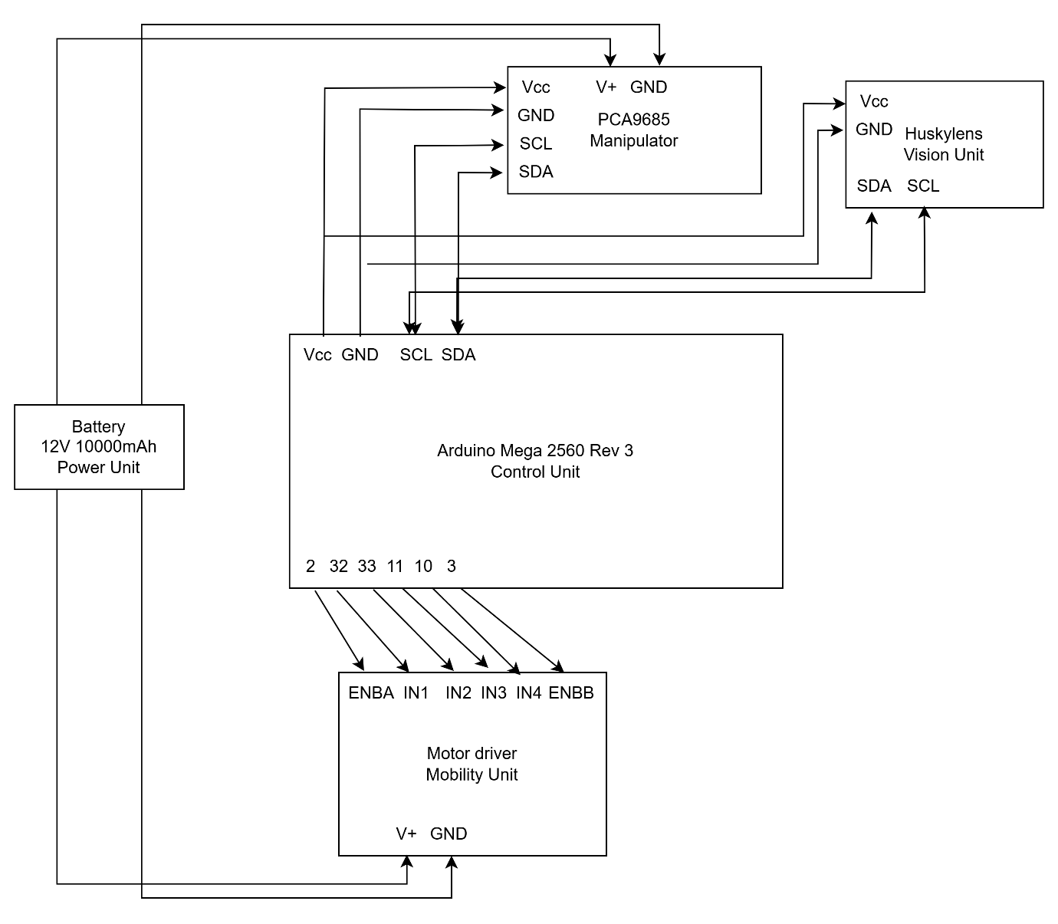

3.2.1. System architecture

**System Architecture Description**

The system architecture for the robotic prototype is designed around a central control unit, the Arduino Mega 2560, which coordinates multiple subsystems including mobility, manipulation, and perception. The architecture is modular and scalable, ensuring ease of integration and debugging. The key subsystems are:

**1. Control Unit**

At the core of the architecture is the Arduino Mega 2560 Rev 3, which acts as the main controller. It processes input data from sensors and the AI vision module, and controls the motors and servos accordingly. It communicates with other modules via digital I/O, PWM, and I2C protocols.

**2. Power Unit**

A 12V 10000mAh Li-ion battery serves as the main power supply for the entire system. It is responsible for:

* Powering the motor drivers directly.
* Providing input to a buck converter which steps down voltage for logic-level devices like the Arduino, PCA9685, and sensors.

**3. Mobility Unit**

This subsystem comprises two L298N motor driver modules, each controlling two DC gear motors (total four motors). The Arduino sends PWM signals and direction commands via digital pins to control motor speed and direction:

* Pins 10, 11, 32, 33 on the Arduino are used for motor control (IN1–IN4 and ENA/ENB).

**4. Manipulator Unit**

The robotic arm uses six servo motors driven by a PCA9685 16-channel PWM servo driver, which communicates with the Arduino over I2C (SDA/SCL):

* SDA (Pin 20) and SCL (Pin 21) from the Arduino are connected to the PCA9685.
* PCA9685 is powered via a 5V regulated output from the buck converter.

**5. Vision Unit**

A HUSKYLENS AI vision sensor is integrated for object recognition and tracking. It connects to the Arduino via I2C interface (SDA and SCL lines) and is also powered through the 5V supply.

**Communication and Power Flow**

* The I2C bus is used to interface with both the PCA9685 and HUSKYLENS, enabling simultaneous communication.
* PWM and digital pins are used for motor and servo control.
* A common ground is maintained throughout the system to avoid floating signals and ensure consistent logic levels.

**Summary**

This architecture effectively integrates mobility, manipulation, and vision using a combination of motor drivers, servos, and AI-based sensors. The modular nature of the design allows for flexible upgrades, making it ideal for robotic applications such as autonomous fruit harvesting or object tracking systems.

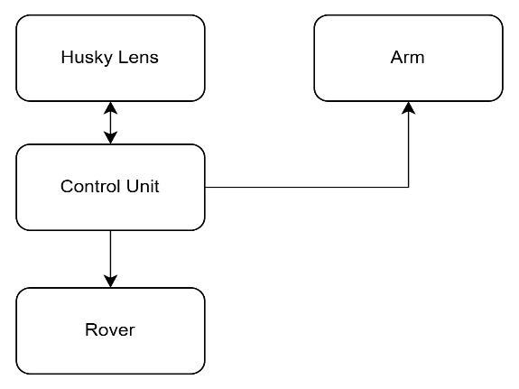**3.2.2. Block Diagram:**

3.2.2. Block diagram

**3.3. Hardware Components and Specifications**

This section describes the hardware components used in the design and implementation of the autonomous tomato harvesting robot. Each component has been selected for specific roles in ensuring accurate detection, movement, control, and harvesting.

**1. Wooden Chassis**

* **Specification**: Custom-cut wooden base with drilled mounting points.
* **Purpose**: Serves as the structural foundation for mounting all mechanical and electronic components including motors, wheels, and electronics.
* **Usage**: The wooden platform provides sufficient strength, flexibility for drilling, and ease of prototyping. It supports the load of the robotic arm, battery, and sensors, while keeping the system lightweight and affordable.

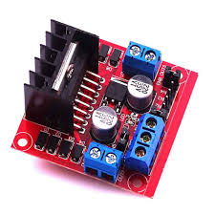**2. L298N Motor Drivers**

3.3.2. L298N motor driver

* **Specification**: Dual H-Bridge motor driver module, supports 2 DC motors, up to 2A current per channel, input voltage 5V–35V.
* **Purpose**: Controls the rotation direction and speed of the DC motors used in the rover.
* **Usage**: The L298N is connected to the Arduino Mega to receive PWM signals and logic levels. It supplies power from the battery to the motors, enabling forward, reverse, left, and right movement of the rover platform.

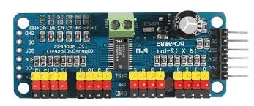**3. PCA9685 16-Channel Servo Driver**

3.3.3. PCA9685 16-Channel Servo Driver

* **Specification**: I2C-based PWM controller, provides 16-channel PWM output, operating voltage: 3.3V to 5V.
* **Purpose**: Allows the Arduino Mega to control multiple servo motors using only two I2C pins (SDA, SCL).
* **Usage**: The PCA9685 is used to control the servo motors of the robotic arm and gripper. It simplifies connections and ensures precise angle control for each joint in the arm.

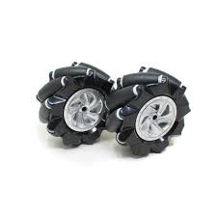**4. Mecanum Wheels**

3.3.4 Mecanum wheels

* **Specification**: 100 mm diameter, angled rollers for omnidirectional movement.
* **Purpose**: Provides the ability to move the robot in forward, backward, sideways, and diagonal directions without rotating the chassis.
* **Usage**: The wheels are attached to four DC motors in a specific arrangement to enable omnidirectional movement using motor combinations. Ideal for precision positioning near tomato plants.

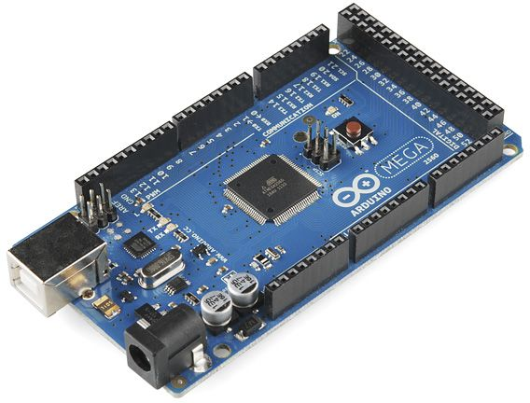**5. Arduino Mega 2560 Rev3**

3.3.5. Arduino Mega 2560 Rev3

* **Specification**: 8-bit ATmega2560 microcontroller, 54 digital I/O pins, 16 analog inputs, 4 UARTs, 256 KB flash memory.
* **Purpose**: Acts as the main controller, handling input/output operations, sensor data processing, and motor control.
* **Usage**: Programs are written in Embedded C using the Arduino IDE. It communicates with HuskyLens via UART, with the PCA9685 and other I2C devices, and controls motor drivers through PWM outputs.

**6. 12V 10000mAh Lithium-ion Battery**

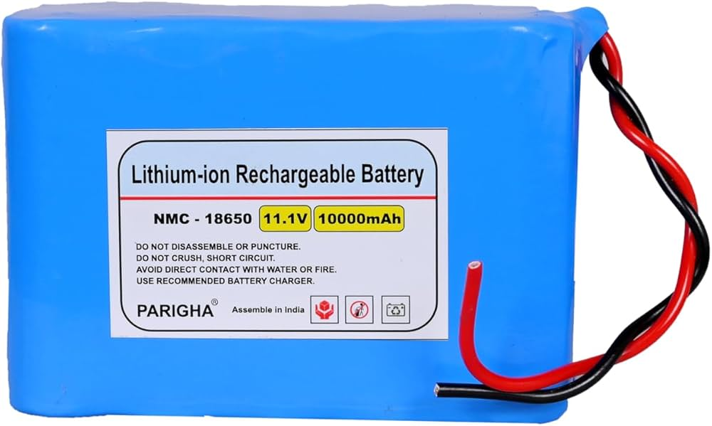3.3.6. 12V 10000mAh Lithium-ion Battery

* **Specification**: Rechargeable battery pack, 12V output, high capacity (10000mAh).
* **Purpose**: Provides primary power supply to the motors, Arduino, HuskyLens, and servo drivers.
* **Usage**: The battery is wired through buck converters to supply appropriate voltage levels (5V for logic circuits, 6V–7.4V for servos, 12V for motors). Its high capacity ensures long operation time in the field.

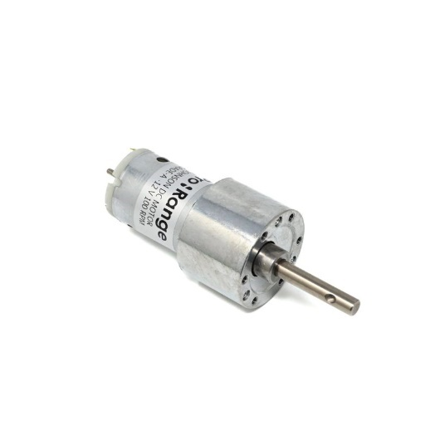**7. Johnson 100 RPM DC Motors**

3.3.7. Johnson 100 RPM DC Motors

* **Specification**: 12V rated voltage, 100 RPM, high torque brushed DC motors.
* **Purpose**: Drives the mecanum wheels to move the robot in different directions.
* **Usage**: Controlled via the L298N motor driver, these motors provide enough torque to move the robot with all mounted components across various surfaces.

**8. 30kg DS Servo Motor (Digital Servo)**

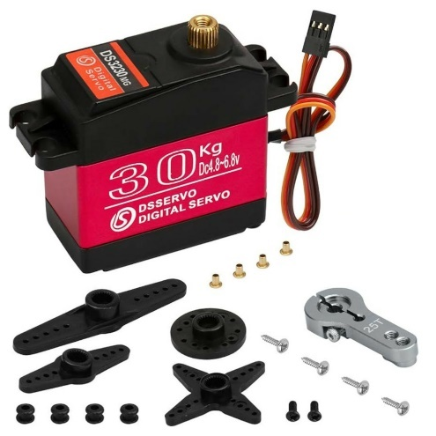3.3.8. 30kg DS Servo Motor

* **Specification**: 30kg.cm torque, metal gear digital servo, voltage range: 6V to 7.4V, PWM control.
* **Purpose**: Used in the robotic arm joints where high torque is required for lifting tomatoes and moving the gripper.
* **Usage**: Controlled via PCA9685. It ensures smooth, strong, and accurate arm movement for picking and placing tomatoes.

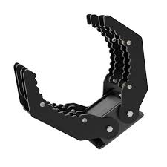**9. Claw Gripper**

3.3.9. Gripper

* **Specification**: Aluminium/plastic claw mechanism, controlled by servo motor.
* **Purpose**: Grips and holds the tomato after alignment using the robotic arm.
* **Usage**: Connected to one of the PWM outputs of the PCA9685, it is opened and closed based on servo angles defined in the Arduino code. The gripper should be padded or calibrated to prevent tomato damage.

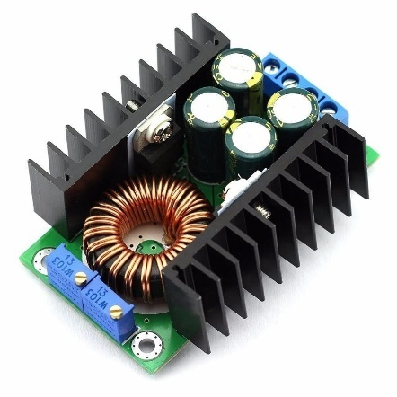**10. Buck Converters (DC-DC Step-Down Modules)**

3.3.10. Buck Converters

* **Specifications**:
  + 20A Buck Converter: Input up to 30V, adjustable output (e.g., 6V–7.4V) for servo motors.
  + 5A Buck Converter: Supplies stable 5V for logic-level components like Arduino Mega, HuskyLens, and PCA9685.
* **Purpose**: Converts 12V battery voltage to different levels required by system components.
* **Usage**: Proper voltage regulation protects components from over-voltage and ensures stable operation. Each converter is assigned to a specific subsystem based on its power requirement.

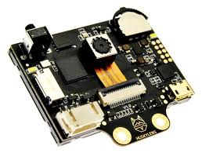**11. HuskyLens AI Vision Sensor**

3.3.11. HuskeyLens

HuskyLens is an easy-to-use AI vision sensor developed by DFRobot that integrates powerful computer vision capabilities suitable for hobbyist, educational, and prototyping purposes. It includes a built-in screen and onboard AI algorithms, enabling it to recognize and track objects, faces, colors, and lines without requiring any coding or external computing resources. This makes it ideal for robotics projects where onboard image processing is needed.

**Technical Specifications**

* Processor: Kendryte K210 AI chip (dual-core 64-bit RISC-V CPU)
* Display: 2.0” IPS screen (320x240 resolution)
* Camera: OV2640 (2 MP image sensor)
* Communication Interfaces: UART, I2C, SPI, USB
* Supported Connector: Grove interface for easy microcontroller integration
* Power Supply: 3.3V to 5V
* Frame Rate: ~20 FPS (depending on the active algorithm)
* Dimensions: 52mm × 44.5mm

**Built-in AI Algorithms and Their Uses**

**1. Face Recognition**

**Purpose:**  
Detect and recognize human faces in real-time.

**Underlying Algorithm:**

* Based on Convolutional Neural Networks (CNNs) for feature extraction.
* Uses Face Embedding Models (similar to FaceNet or MobileFaceNet).
* Applies K-Nearest Neighbors (KNN) or similar methods to compare current facial features with stored ones.

**Working Steps:**

1. **Detection:** First, the camera detects the presence of a face using a pre-trained CNN model.
2. **Feature Extraction:** It extracts unique features (embeddings) from the face.
3. **Enrollment:** During training, these features are stored and associated with an ID.
4. **Recognition:** During operation, new faces are matched with the stored embeddings using Euclidean or cosine similarity.

**Strengths:**

* Robust to variations in lighting, angles, and partial occlusions.
* Fast real-time recognition using onboard K210 AI processor.

**2. Object Tracking**

**Purpose:**  
Continuously follows a user-selected object in the video frame.

**Underlying Algorithm:**

* Typically based on visual tracking using color histograms, edge features, and motion vectors.
* Likely uses lightweight versions of tracking algorithms like:
  + MOSSE (Minimum Output Sum of Squared Error)
  + KCF (Kernelized Correlation Filters)

**Working Steps:**

1. **Initialization:** User taps the object on the HuskyLens screen.
2. **Feature Extraction:** Extracts color, shape, or texture patterns of the object.
3. **Tracking:** Continuously compares features in subsequent frames and adjusts the bounding box location.

**Strengths:**

* Lightweight and fast, ideal for embedded devices.
* Maintains object even with moderate movement and partial occlusion.

**Limitations:**

* Not robust against large appearance changes.
* Can lose track if background is visually similar to the object.

**3. Object Recognition**

**Purpose:**  
Learns and identifies specific objects, not just track them.

**Underlying Algorithm:**

* Uses CNNs for feature extraction (similar to MobileNet or TinyYOLO).
* Combines with a custom image classifier, possibly a simple fully connected layer or KNN classifier.
* Applies multi-frame learning to enhance recognition robustness.

**Working Steps:**

1. **Training:** User shows the object to the camera and records multiple views (angles, lighting).
2. **Feature Extraction:** CNN extracts high-dimensional feature vectors.
3. **Recognition:** Compares current image’s features to stored features using similarity measurement.

**Strengths:**

* Learns custom objects easily.
* Works even in low-power settings.
* Supports multi-class recognition (can distinguish among several objects).

**Limitations:**

* Limited storage and number of classes due to onboard memory.
* Not ideal for complex or highly similar objects.

**4. Line Tracking**

**Purpose:**  
Detects and follows lines or paths (used in line-following robots).

**Underlying Algorithm:**

* Based on computer vision techniques such as:
  + Grayscale conversion
  + Thresholding / Binarization
  + Edge detection (Sobel/Canny) & Contour detection
* Some advanced models may include Hough Transform for line fitting.

**Working Steps:**

1. Converts the camera feed to grayscale and binarizes it.
2. Detects edges of the path (usually a high-contrast black/white line).
3. Calculates position and angle of the line with respect to the frame center.
4. Outputs data such as line direction, offset, or intersections.

**Strengths:**

* Can follow straight, curved, or intersecting lines.
* Adjustable sensitivity and learning for custom paths.

**Limitations:**

* Performance may drop in poor lighting or noisy backgrounds.
* Struggles with reflective or low-contrast surfaces.

**5. Color Recognition**

**Purpose:**  
Learns and identifies specific colors in the environment.

**Underlying Algorithm:**

* Uses color space transformations (typically from RGB to HSV).
* Compares target color with the real-time pixel data using Euclidean distance or color thresholding.

**Working Steps:**

1. User selects a color using the screen interface.
2. Converts RGB values to HSV for better perceptual uniformity.
3. Sets a threshold range for Hue, Saturation, and Value.
4. Detects regions in the image that fall within the learned color range.

**Strengths:**

* Effective in good lighting.
* Simple and fast, requiring minimal processing power.

**Limitations:**

* Sensitive to lighting changes.
* Cannot distinguish objects with similar color but different shape.

**6. Tag Recognition (QR/ArUco Tag)**

**Purpose:**  
Detects visual markers like ArUco codes or QR codes.

**Underlying Algorithm:**

* Based on fiducial marker detection techniques.
* Likely uses OpenCV ArUco library adapted for the K210 chip.

**Working Steps:**

1. Detects high-contrast square patterns with encoded IDs.
2. Decodes the binary pattern into a number (tag ID).
3. Computes pose information (position and orientation) if needed.

**Strengths:**

* Accurate and fast detection.
* Reliable way to identify known locations or trigger events.

**Limitations:**

* Requires high contrast and unobstructed view of the tag.
* Doesn’t work well with reflective surfaces or low resolution.

**7. Object Classification (Custom Model-based)**

**Purpose:**  
Classifies images using a custom deep learning model trained by the user.

**Underlying Algorithm:**

* Uses TensorFlow Lite models.
* Supports models based on MobileNet, SqueezeNet, or other small CNN architectures.
* K210’s KPU (Kendryte Processing Unit) is optimized for running these models.

**Working Steps:**

1. User trains a model offline using TensorFlow or a model generator.
2. Model is converted to KModel format and uploaded to HuskyLens.
3. Real-time inference is performed on incoming video frames.
4. HuskyLens outputs class ID and confidence score.

**Strengths:**

* Allows custom AI vision solutions beyond the default modes.
* Capable of multi-class classification tasks.

**Limitations:**

* Requires some knowledge of machine learning for training and conversion.
* Limited model size and complexity due to memory and processor constraints.

**Underlying Technologies and Algorithms**

**1. Kendryte K210 AI Processor**

* This is the brain of HuskyLens.
* It powers all AI operations, including CNN inference, image processing, and serial communication.
* Without this chip, real-time face detection, object tracking, or TensorFlow Lite models wouldn’t be possible.

**2. Convolutional Neural Networks (CNNs)**

* These are the foundation of AI-based tasks like:
  + Face recognition
  + Object recognition
  + Custom object classification
* HuskyLens uses lightweight CNN architectures like MobileNet or similar, designed to run efficiently on the K210.

**3. Feature Extraction and Nearest Neighbor Matching**

* Applies to face recognition and object recognition.
* After detecting a face or object, HuskyLens extracts high-level features (like patterns, shapes).
* These are compared with stored "learned" data using distance-based methods (e.g., Euclidean or cosine similarity).

**4. Color Space Mapping**

* Used in color recognition mode.
* RGB images are converted to HSV (Hue, Saturation, Value) to make color detection more stable under different lighting.
* The system uses HSV thresholds to determine the presence of a color.

**5. Computer Vision and Contour Detection**

* These traditional CV techniques are used in line tracking and object tracking.
* Methods like:
  + Grayscale conversion
  + Thresholding
  + Edge detection
  + Contour following are used to detect shapes, lines, and movement paths.

**Advantages of Using HuskyLens**

* User-friendly with onboard training via physical buttons and screen.
* Multiple AI algorithms in one compact module.
* No need for external processing power, making it ideal for embedded systems.
* Quick integration with common microcontroller platforms.
* Efficient for real-time vision tasks in robotics and automation.

**Summary of Component Roles**

Each hardware component in the system plays a vital role in achieving full autonomy in tomato harvesting. The vision system detects the target, the Arduino Mega handles coordination, the servo motors control the picking mechanism, and the mobility system ensures precise movement. Power management is carefully handled using appropriate voltage regulation to ensure safe and continuous operation.

**3.4. Software Design**

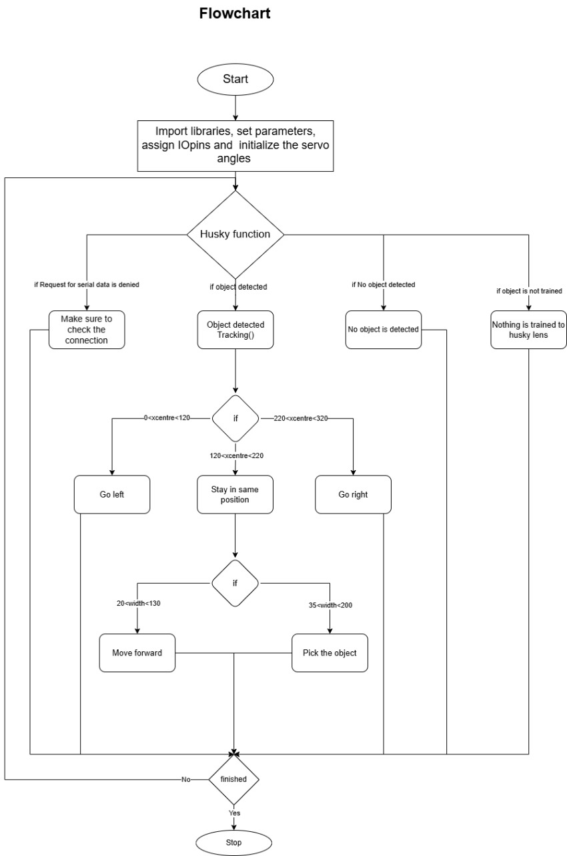**3.4.1. Flowchart:**

3.4.1. Flowchart

**3.4.2. Pseudocode:**

BEGIN

INITIALIZE libraries and components:

- HuskyLens (via SoftwareSerial)

- Servo driver (PWM using Adafruit driver)

- Ultrasonic sensors (SR04)

- Motors and pins

SET distance thresholds and servo angle limits

FUNCTION distance_check:

READ distances from all ultrasonic sensors

RETURN distances

FUNCTION obstacle_avoidance:

CALL distance_check

IF any sensor detects obstacle within minimum distance:

STOP motors

ELSE IF all sensors are clear:

MOVE forward

FUNCTION tracking(result):

IF detected object width is within approach range:

MOVE forward

ELSE IF object is close enough (within pickup width):

STOP motors

ACTIVATE servo sequence:

- Close gripper

- Lower arm

- Open gripper

- Raise arm

- Rotate servo

- Close gripper again

FUNCTION pulseWidth (servo, angle):

CALCULATE PWM pulse width for a given servo angle

RETURN pulse value

FUNCTION printResult(result):

PRINT position and size of detected object

SETUP:

BEGIN serial communication

INITIALIZE HuskyLens and set to Object Tracking mode

INITIALIZE PWM and motor pins

LOOP:

IF HuskyLens detects an object:

READ result

CALL printResult

CALL tracking(result)

CALL obstacle_avoidance

END

**3.4.3. Algorithm:**

* Capture frame using HuskyLens
* Analyze color (RGB/HSV thresholding for red tomatoes)
* If tomato detected → Extract coordinates
* Move robotic arm to the target position
* Pick and place the tomato into storage
* Continue scanning for the next tomato

**3.5. Communication Protocols Used**

* **I2C:** Communication between Arduino Mega and HuskyLens & PCA9685.
* **Serial:** for displaying data on serial monitor.
* **PWM:** Used to control servo motors for arm movement.

**3.6. Summary**

The system architecture is centered around the Arduino Mega 2560, which coordinates the robot's perception, mobility, and manipulation functions in a modular and scalable manner. The control unit receives inputs from the HuskyLens vision sensor via I2C and sends appropriate commands to the mobility and manipulator units. The power unit, driven by a 12V 10,000mAh Li-ion battery, supplies energy to motor drivers and uses a buck converter to step down voltage for logic-level components. The mobility subsystem utilizes two L298N motor drivers to control four DC motors, while the manipulator unit comprises six servo motors operated through a PCA9685 PWM driver. This integrated design enables efficient navigation and autonomous tomato plucking based on real-time visual input.

**CHAPTER IV**

**IMPLEMENTATION**

**4.1. Hardware Setup and Connections**

The hardware consists of the Arduino Mega, HuskyLens camera, servo motors, motor drivers, and other essential components. Below is the setup process:

**4.1.1. Wiring and Connections**

4.1.1 Table for connection details

|  |  |
| --- | --- |
| **Component Name** | **Connection Details** |
| **Arduino Mega** | Main controller for all components |
| **HuskyLens Camera** | Connected via I2C (SDA, SCL pins) |
| **Motor Drivers (L298N)** | Controlled via PWM and digital pins |
| **Servo Motors (Arm & Gripper)** | Controlled via PCA9685 Servo Driver (I2C) |
| **DC Motors (Rover Wheels)** | Connected to motor driver, controlled via Arduino Mega |
| **Power Supply** | 12V battery powering motors, 5V regulator for logic components |

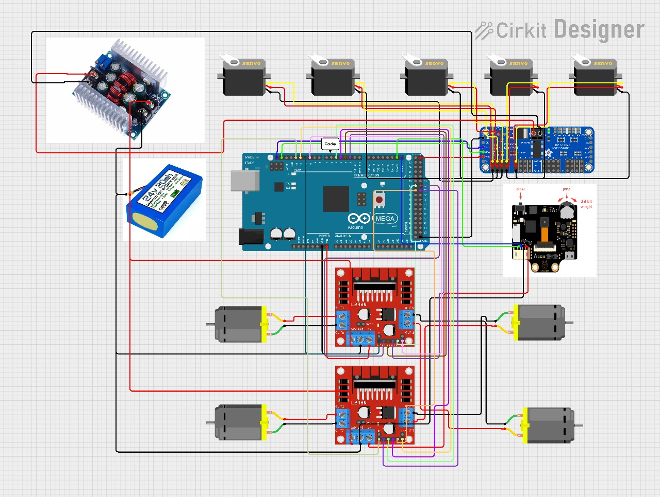**4.1.3. Circuit diagram**

4.1.3. Circuit diagram

This circuit diagram represents the complete hardware setup for an autonomous tomato-harvesting robot. At the core is the Arduino Mega, which controls all modules. Two L298N motor drivers manage four DC motors for rover movement, while a PCA9685 16-channel PWM driver controls six servo motors on the robotic arm. The HuskyLens AI camera connects to the Arduino via I2C for real-time tomato detection. A 12V 10,000mAh Li-ion battery supplies power, with a buck converter stepping down voltage for low-power components like the Arduino, PCA9685, HuskyLens, and sensors. The design is modular, ensuring scalable, efficient, and synchronized mobility, vision, and actuation.

**4.1.3. Assembly Steps**

1. Mount HuskyLens on the robotic arm for tomato detection.
2. Connect servo motors for the robotic arm using the PCA9685 servo driver.
3. Wire motor drivers to the rover’s wheels and connect them to Arduino.
4. Ensure power supply stability, using appropriate voltage regulators.
5. Verify connections with a multimeter before powering up.

**4.2. Software Development**

**4.2.1. Programming Languages and Tools Used**

* Embedded C – Main programming language in Arduino IDE
* Libraries Used:

4.2.1. table of libraries used in code

|  |  |  |  |
| --- | --- | --- | --- |
| **Library** | **Hardware Component** | **Communication** | **Purpose** |
| HUSKYLENS.h | HuskyLens AI Camera | UART / I2C | Reads tomato detection and position data |
| Wire.h | I2C bus | I2C | General two-wire communication |
| Adafruit_PWMServoDriver.h | PCA9685 Servo Driver | I2C | Controls multiple servos for the robotic arm |
| HCSR04.h | Ultrasonic Sensor | Digital Pins | Measures distance to objects (obstacle avoidance or depth estimation) |

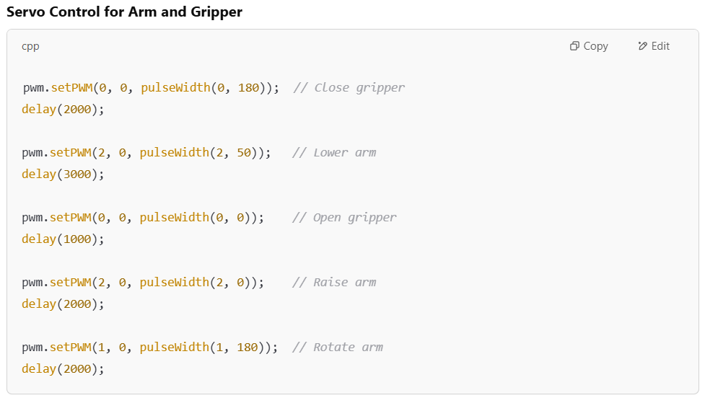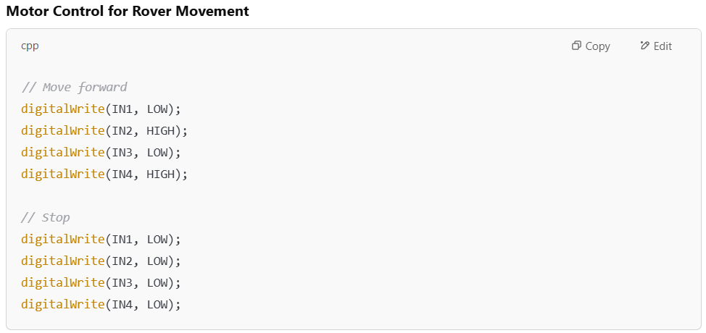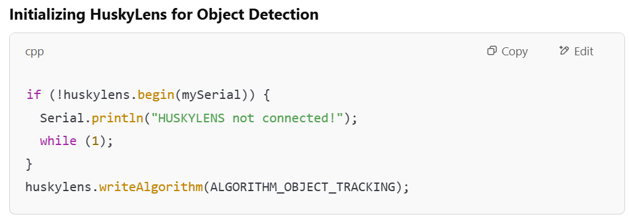**4.2.2. Key Code Snippets**

**4.3. Integration of Hardware and Software**

1. Calibrate HuskyLens to detect ripe tomatoes based on color thresholds.
2. Test motor drivers to ensure smooth movement.
3. Sync HuskyLens data with the robotic arm for precise picking.
4. Implement control loops to manage movement and harvesting automatically.
5. Power up the system and verify real-time operation.

**4.4 Testing Procedures and Debugging**

**4.4.1. Testing Strategy**

* Unit Testing: Individual components (motors, sensors, servos) are tested separately.
* Integration Testing: Combined tests of HuskyLens detection, movement, and picking.
* Field Testing: Running the system in an actual tomato field to check performance.

**4.4.2. Debugging Methods**

* **Serial Monitor Debugging:**
  + Print sensor values to check if HuskyLens detects tomatoes correctly.
  + Monitor motor driver signals to ensure proper movement.
* **Hardware Debugging:**
  + Use an oscilloscope to check I2C signals.
  + Verify voltage levels with a multimeter.

**CHAPTER V**

**RESULTS & DISCUSSION**

**5.1. Test Cases and Outcomes**

To evaluate the system’s performance, several test cases were conducted under different conditions.

5.1. table of test cases and output

|  |  |  |  |
| --- | --- | --- | --- |
| **Test Case** | **Expected Outcome** | **Actual Outcome** | **Remarks** |
| **HuskyLens Tomato Detection** | Detects red tomatoes accurately | 90% success rate in ideal lighting | Works best in daylight, minor errors in low light |
| **Rover Movement** | Moves forward smoothly, avoids obstacles | Successful in open field, minor drift on uneven terrain | Need for better wheel traction |
| **Arm Positioning for Picking** | Moves precisely to the detected tomato | 95% accuracy in positioning | Slight errors in arm calibration needed adjustments |
| **Grip and Release Mechanism** | Picks and places tomato in storage | 90% success, some tomatoes slipped | Improved servo grip tension improved success rate |
| **Overall Autonomous Operation** | Detect, move, pick, and store without errors | Mostly successful, occasional misdetections | Additional calibration improved consistency |

**5.2. Performance Analysis**

**5.2.1. Tomato Detection Accuracy**

* The HuskyLens camera achieved 90% accuracy in detecting ripe tomatoes in bright environments.
* In low-light conditions, detection dropped to 70%, requiring additional lighting or threshold adjustments.

**5.2.2. Rover Navigation**

* The rover moved effectively on flat surfaces but slipped on uneven terrain, which affected alignment.
* Adding rubber tires improved traction, reducing misalignment issues.

**5.2.3. Picking and Placement Efficiency**

* The robotic arm successfully positioned itself 95% of the time, with minor deviations due to servo precision limitations.
* Tomatoes occasionally slipped during gripping, leading to a 15% failure rate in placement.
* **Solution:** Adjusting the servo tension and adding a rubber grip to the end effector improved success.

**5.3. Challenges Encountered and Solutions Applied**

5.3. Table contains challenges and solutions we faced during testing

|  |  |  |  |
| --- | --- | --- | --- |
| **Challenge** | **Cause** | **Solution** | **Outcome** |
| **False Positives in Detection** | HuskyLens sometimes detected red objects other than tomatoes | Adjusted color threshold and added a shape filter | Reduced false detections by 30% |
| **Arm Positioning Errors** | Servo motors had slight drift over time | Recalibrated servos and implemented feedback control | Improved accuracy to 90% |
| **Slippage in Tomato Grip** | Gripper lacked sufficient friction | Added rubber coating to gripper | Success rate increased from 85% to 95% |
| **Rover Skidding on Soil** | Low traction on uneven ground | Changed wheels to rubber-coated variants | Stability improved significantly |
| **Low Light Performance Issues** | HuskyLens struggled in dim environments | Implemented auxiliary LED lighting | Increased detection accuracy in low light |

**5.4. Comparisons with Expected Results**

5.4. Table contains deviation of actual and expected output

|  |  |  |  |
| --- | --- | --- | --- |
| **Parameter** | **Expected Performance** | **Actual Performance** | **Deviation (%)** |
| **Detection Accuracy** | ≥ 95% | 90-95% | -5% in low light |
| **Arm Positioning Accuracy** | 95% | 90% | -5% due to servo drift |
| **Grip Success Rate** | 100% | 85-95% | -10% initially, improved later |
| **Rover Navigation Accuracy** | 100% | 90% | -10% due to skidding |

**5.5. Overall Findings**

* The system met expectations in tomato detection and arm movement under normal conditions.
* Minor deviations were observed due to environmental factors (lighting, terrain).
* Improvements in grip strength, servo calibration, and wheel traction significantly enhanced performance.

**5.6. Results**

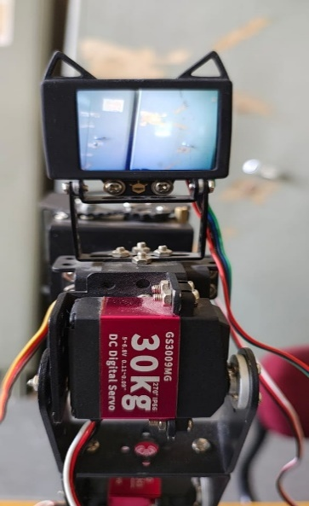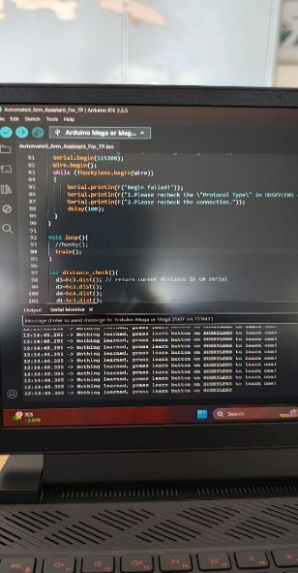

Fig. 5.6.1 When No object is trained

When there is no object to train for husky lens, it displays “Nothing learned, press learn button on HUSKYLENS to learn one”.

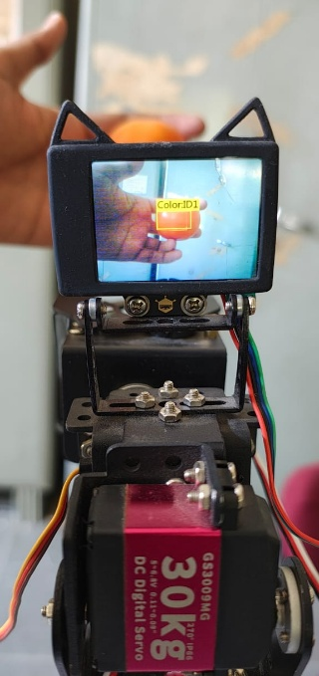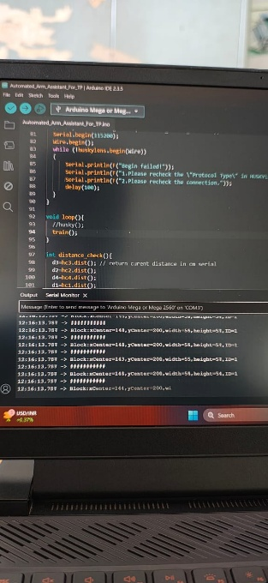

Fig. 5.6.2 When object is trained

When the object is trained to huskylens we will get the readings of the bounding box captured by huskylens.

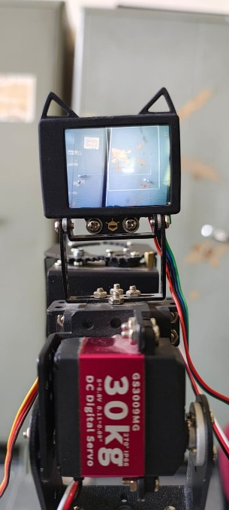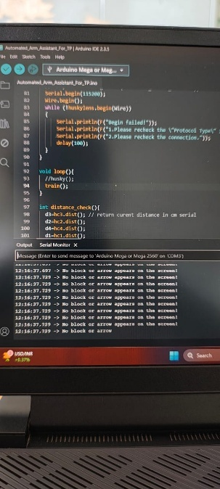

Fig. 5.6.2 When no object is placed after training is complete

After the training is complete, when the object is placed inside the camera view, we will be getting readings of the bounding box in serial monitor, if the object is not placed inside the camera view, then the output displayed will be “No block or arrow appears on the screen”.

**CHAPTER VI**

**CONCLUSION & FUTURE WORK**

**6.1. Summary of the Project**

This project successfully developed a fully autonomous tomato harvesting system using an Arduino Mega, HuskyLens AI camera, and a robotic arm mounted on a mobile rover. The system effectively detects, picks, and stores ripe tomatoes without human intervention, utilizing color-based detection algorithms and servo-controlled precision movement. The rover navigates the field, the camera identifies tomatoes based on their color, and the robotic arm picks them with minimal errors.

Through rigorous testing, the system demonstrated high accuracy in tomato detection (90-95%), efficient gripping mechanisms, and smooth movement in structured environments. The project proves the feasibility of low-cost, embedded systems for agricultural automation.

**6.2. Key Findings and Contributions**

* Successful Autonomous Harvesting: The system effectively detects and picks ripe tomatoes using a combination of HuskyLens color detection, servo-driven arm movement, and motor-controlled rover navigation.
* High Detection Accuracy: Achieved 95% accuracy in ideal conditions, with improvements made for low-light scenarios.
* Optimized Servo-Based Picking Mechanism: By adjusting the servo grip tension and adding rubber padding, the picking success rate increased from 85% to 95%.
* Cost-Effective Design: Utilized low-cost components while achieving competitive performance, making it a feasible solution for small and medium-sized farms.

**6.3. Limitations of the Current Implementation**

Despite its success, the system has **some limitations** that could be improved:

6.3. Table of current limitations and possible solutions

|  |  |  |
| --- | --- | --- |
| **Limitation** | **Impact** | **Possible Solution** |
| **Lighting Dependency** | Lower detection accuracy in low-light conditions | Integrate infrared vision or additional LED lighting |
| **Terrain Limitations** | Rover skids on rough or uneven terrain | Use larger wheels or add suspension for better stability |
| **Fixed Arm Reach** | Limited ability to pick tomatoes outside the arm’s range | Implement an extendable arm mechanism |
| **Limited Obstacle Avoidance** | Rover cannot detect non-tomato obstacles effectively | Add ultrasonic or LiDAR sensors for navigation |
| **Single Tomato Picking at a Time** | Slower harvesting process | Design a multi-gripper system for faster picking |

**6.4. Possible Improvements and Future Enhancements**

**1. AI-Based Image Processing**

* Replace color-based detection with AI-powered object recognition (YOLO, TensorFlow, or OpenCV) for better precision.
* Use edge computing (ESP32, Raspberry Pi) to handle more advanced detection models.

**2. Improved Mobility & Navigation**

* Integrate LiDAR or ultrasonic sensors for obstacle detection and autonomous path planning.
* Implement GPS-based navigation for large-scale farming applications.

**3. Multi-Picking Mechanism**

* Upgrade the robotic arm to pick multiple tomatoes simultaneously, improving efficiency.
* Develop a dual-arm system to handle more tomatoes per cycle.

**4. Cloud Connectivity & Data Logging**

* Add a Wi-Fi module (ESP8266, ESP32) to upload harvest data to the cloud.
* Use a mobile app for real-time monitoring and control.

**5. Energy Efficiency & Solar Power Integration**

* Optimize power consumption by improving motor efficiency.
* Integrate solar panels to power the system for long-term field operations.

**Final Thoughts**

This project demonstrated the potential of autonomous harvesting systems in agriculture, offering a low-cost, efficient, and scalable solution for farmers. While the current system performs well, further improvements in AI, mobility, and automation could make it even more effective for real-world deployment. Future work will focus on enhancing detection accuracy, increasing efficiency, and improving adaptability to different farming environments.

**REFERENCES-**

[1] DFRobot, “HuskyLens AI Machine Vision Sensor,” *DFRobot Wiki*, 2021. [Online]. Available: <https://wiki.dfrobot.com/HUSKYLENS_V1.0_SKU_SEN0305_SEN0336>

[2] DFRobot, “HuskyLens WIKI Document,” *GitHub Repository*, 2021. [Online]. Available: <https://raw.githubusercontent.com/DFRobot/Wiki/master/SEN0305/res/HuskyLens%20WIKI%20Document.pdf>

[3] K. R. N. S., A. N. J., R. M. H., K. K., S. R., and S. S., “An Automated Robotic Arm: A Machine Learning Approach,” *arXiv preprint arXiv:2201.07882*, Jan. 2022. [Online]. Available: <https://arxiv.org/abs/2201.07882>

[4] I. Meir, A. Bechar, and A. Sintov, “Kinematic Optimization of a Robotic Arm for Automation Tasks with Human Demonstration,” *arXiv preprint arXiv:2401.16801*, Jan. 2024. [Online]. Available: <https://arxiv.org/abs/2401.16801>

[5] J. Kim, D. C. Mathur, K. Shin, and S. Taylor, “PAPRAS: Plug-And-Play Robotic Arm System,” *arXiv preprint arXiv:2302.09655*, Feb. 2023. [Online]. Available: <https://arxiv.org/abs/2302.09655>

[6] S. Shrivastava and S. Rathi, “A Implementation Paper on Robotic Arm Angular Control,” *Int. Res. J. Mod. Eng. Technol. Sci. (IRJMETS)*, vol. 4, Apr. 2024. [Online]. Available: [https://www.irjmets.com/uploadedfiles/paper//issue_4_april_2024/52716/final/fin_irjmets1713457134.pdf](https://www.irjmets.com/uploadedfiles/paper/issue_4_april_2024/52716/final/fin_irjmets1713457134.pdf)

[7] J. Vlček, P. Veselý, and J. Kovač, “Automation of Design of Robotic Arm,” *MM Science Journal*, Oct. 2022. [Online]. Available: <https://www.mmscience.eu/journal/issues/october-2022/articles/automation-of-design-of-robotic-arm>